Marine Dealer Checklist of Multi-Location Management Metrics
“A person without a goal is like a ship without a rudder.”

Finance:

- Warranty collection
- Gross Profit
- Finance and back-end profit penetration
- P&L
- Consumption
- AR reports
- AP reports

Parts & Inventory:

- Track Inventory Turns
- Track Aging Inventory
- Track Special Orders (Required and Outstanding)
- Track Aging Purchase Orders
- Value of Unit/Parts inventory

- Track mechanic productivity
- Track Repair Event Cycle Time (RECT)
- Time to replenish out-of-stock parts
- Warranty coverage authorization time
- Benchmark your time against dealers in your region
- Service revenue by location
- Work Orders created, opened, finalized

Service:

- Salesperson performance
- Activity metrics (meetings, calls/emails, sales quotes)
- Sold units
- Commissions
- Sales by location
- Number of open/closed deals by period
- Lead conversion

Sales:
Fuel the Success of Your Marine Dealership with IDS
IDS isn’t just a dealer management system. It’s an end-to-end ecosystem that seamlessly integrates every department of your marine dealership from Accounting to Sales to Service.
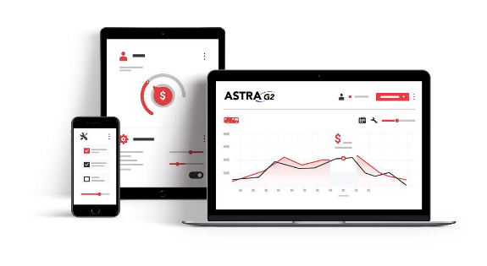

Call IDS to learn more at 800-769-7425

